northwind & Contoso

A Shared Vision. A Strong Partnership.

Exclusive Partner Agreement Analysis

Megan Bowen | March 2016

Contents

Contents 1

Executive summary 2

Forty years of sights and sound 2

Shared values 3

Coming Innovation 3

Responsibility 3

Northwind sales analysis 2013 4

Long-term trends 4

Customer research 5

A trusted brand 5

New products—2016 and beyond 6

Executive summary

Contoso and Northwind have a long and trusted relationship that spans more than three decades. Their shared core values and vision for how the landscape of technology will evolve has benefited both companies over the years and will continue to do so in the future.[1]

A sales analysis from 2014 showed that 42.5 percent of Northwind electronics sales were of Northwind-brand products created by Contoso. A multiyear analysis showed that while Northwind sales have remained relatively steady since 2007, Northwind-brand products created by Contoso have been a steadily increasing share of those sales.

Customer research conducted in early 2015 determined that consumer trends are favorable to Northwind/Contoso products, hitting a sweet spot that consumers are looking for: innovative, good-quality products for a competitive price from companies they know and trust.

With exciting sustainability programs and new, innovative products on the horizon, a reinvigoration of the exclusive Northwind/Contoso partnership will clearly benefit both companies.

## Forty years of sights and sound

Contoso produced the first Northwind-branded music center in November 1974, and Northwind released it just in time for the holidays. It was a hit. Word spread all across Cleveland, Ohio that Northwind was the place to go for the latest stereo equipment. Toledo followed soon after.

In 1975, Northwind became known for TVs too, when it released the Contoso-produced CR-113. Since then, Northwind and Contoso have grown into global companies, but neither organization has forgotten the values that the companies were founded on.

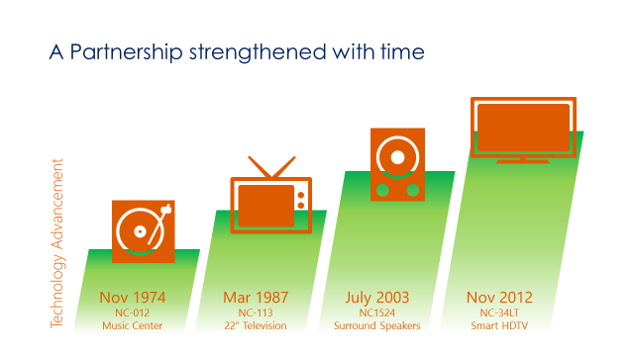

Shared values

## Coming Innovation

From that first music center onward, Northwind and Contoso have been about pushing the boundaries of what’s possible. Thanks to consistent and substantial investments in research and development, Contoso and Northwind have launched a variety of cutting-edge products over the years. Now, Northwind and Contoso are leading the market with new breakthroughs in smart TVs and 3D TVs, true surround-sound stereo systems, and immersive home theatre experiences.

**Innovation. Responsibility.**

Those words have driven both companies to great heights, and through it all, both companies have remained true to these values. Let’s look at each of these in more detail.

## Responsibility

Joe and Jack were humble men. They knew they couldn’t have succeeded without the help of the thousands of employees and millions of customers who bought their products. They knew they had a responsibility to all of these people: produce the best products with the best and most sustainable materials available, use the fairest labor practices, offer the best customer service, and provide the best wages and benefits possible for their employees.

**CONTOSO REUSES AND RECYCLES 55% OF PARTS**

BROUGHT BACK TO NORTHWIND TO RECYCLE

TV MANUFACTURED BY CONTOSO

TV BOUGHT BY CONSUMER

Northwind sales analysis 2015

Setting aside the long history and strong vision of both companies, we can focus on current numbers and see that the Northwind/Contoso relationship is stronger than ever.

In 2015, Northwind’s worldwide sales topped $354 million. Of that, 36.7 percent was from the sale of electronics. In that category, 42.5 percent of Northwind sales were of Contoso products, and due to Northwind’s exclusive contract with Contoso, Northwind saw a profit margin from Contoso-produced products that was 17.5 percent higher than sales of similar products manufactured by other brands.

In the flat-screen TV category, Northwind-brand TVs manufactured by Contoso comprised 47.2 percent of Northwind sales, an increase of 5.4 percent compared to 2012. Meanwhile, in the stereo category, Contoso-produced Northwind-branded made up 41.4 percent of Northwind sales, a 7.8 percent increase over 2012.

## Long-term trends

A multiyear analysis of Northwind product sales shows that while Northwind sales have remained relatively steady over the past five years, Northwind brand products created by Contoso have been a steadily increasing share of those sales.

47% of overall sales from Contoso products

In 2007, Contoso products comprised 35.2 percent of overall Northwind sales. By 2009, that number had increased to 39.8 percent, and by 2011, it had increased to more than 42 percent of overall Northwind electronics sales.

Customer research

A customer research survey, co-sponsored by Contoso and Northwind and conducted at the beginning of 2013, asked consumers why they chose to buy Northwind-brand electronics over other name brands.

The phrases that emerged most often were “best value” (26 percent), “trusted” (23 percent), “good quality” (21 percent), and “innovative” (19 percent). All of these phrases map back to both companies’ core values, proving that Northwind’s and Contoso’s shared approach to business is resonating.­

## A trusted brand

To investigate longer-term trends, we again turned to customer research to determine why consumers were turning to the Northwind brand in droves. Not surprisingly, the worldwide recession that began in 2008 has been a major factor. With less discretionary income, consumers are turning to trusted brands that are perceived to strike the proper balance of being good quality yet still a good value for the money.

Northwind products hit the sweet spot that consumers are looking for: innovative, good-quality products for a good price from companies they know and trust.

Environmental award

Brand loyalty 80%

Sales up by 13%

New products—2016 and beyond

With Northwind support, Contoso research and development has produced some of the most innovative electronics products of the past 40 years. While the Northwind brand has always been known for good quality and value, in the next two years, Contoso plans to unveil a suite of high-end products at affordable price points that consumers may be accustomed to seeing only from upscale electronic brands.

Contoso products that are scheduled to launch in 2016 and 2017 include cutting-edge smart TVs, 3D TVs, true surround-sound stereo systems, and immersive home theatre packages. Renewal of the Northwind/Contoso partnership will ensure that these products will be available exclusively at Northwind retail outlets worldwide.

Here’s a sneak peek at a few of the products that Contoso R&D currently has in development.

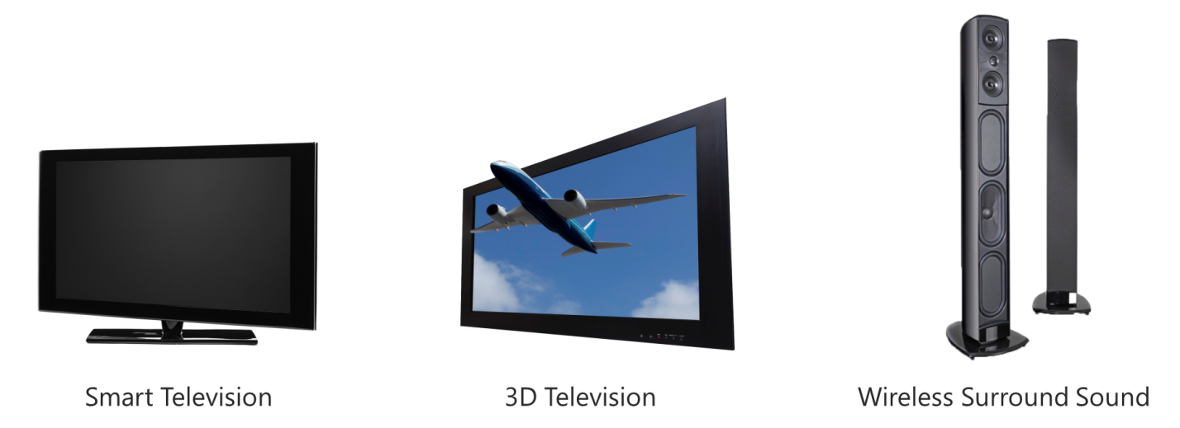

1. See “Joint Technology Roadmap” presentation for more details